**Taria Manual**

Pull the game from <https://github.com/DavidPeet8/Terarriag12>. It works best to pull from the Git Bash outside of the IDE. The game should run in Netbeans or IntelliJ.

In the IDE open and run the project /TerrariaG12/Code/Releases/Release6. You will see a window logon screen as the menu screen. 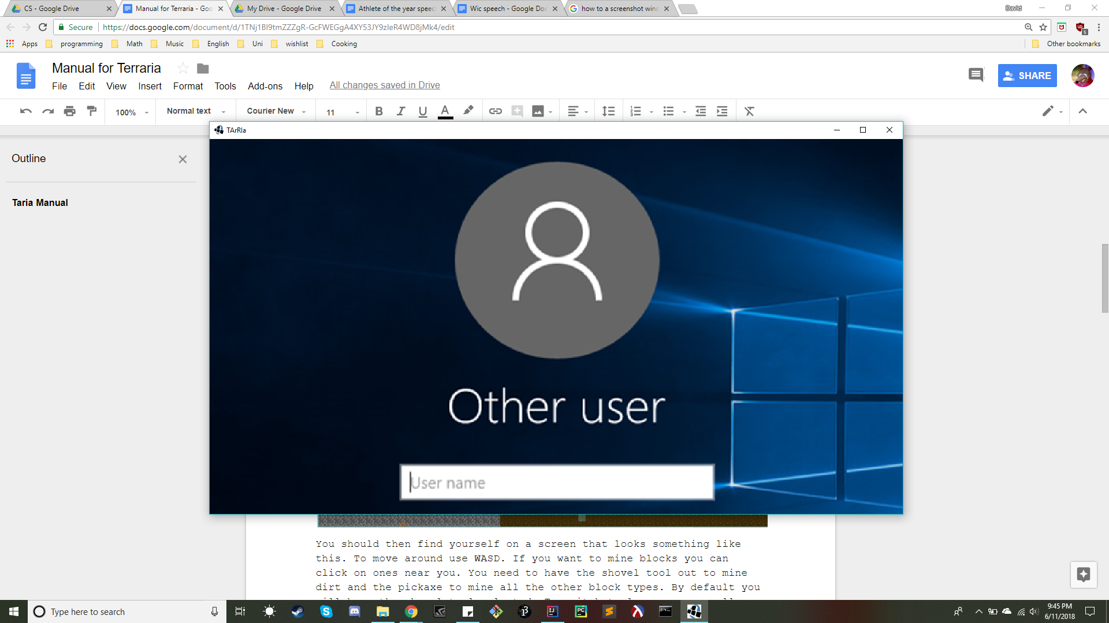

To move to the load screen press the spacebar. The Load screen will look like this.

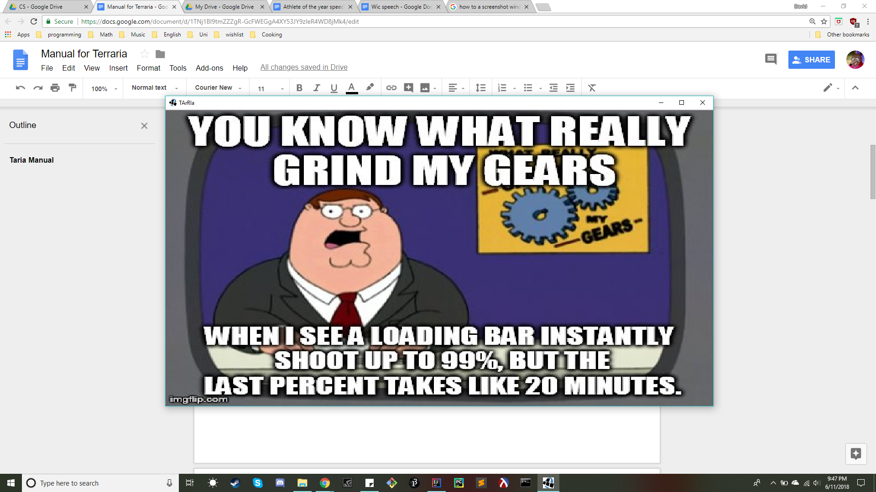

To move to the Play screen and start the game press the spacebar again.

You should then find yourself on a screen that looks something like this. To move around use WASD. If you want to mine blocks you can click on ones near you. You need to have the shovel tool out to mine dirt and the pickaxe to mine all the other block types. By default you will have the shovel tool selected. To switch tools you can scroll with the mousewheel. You can see which tool you have by looking at the top of the screen. Your current tool is surrounded by a black box.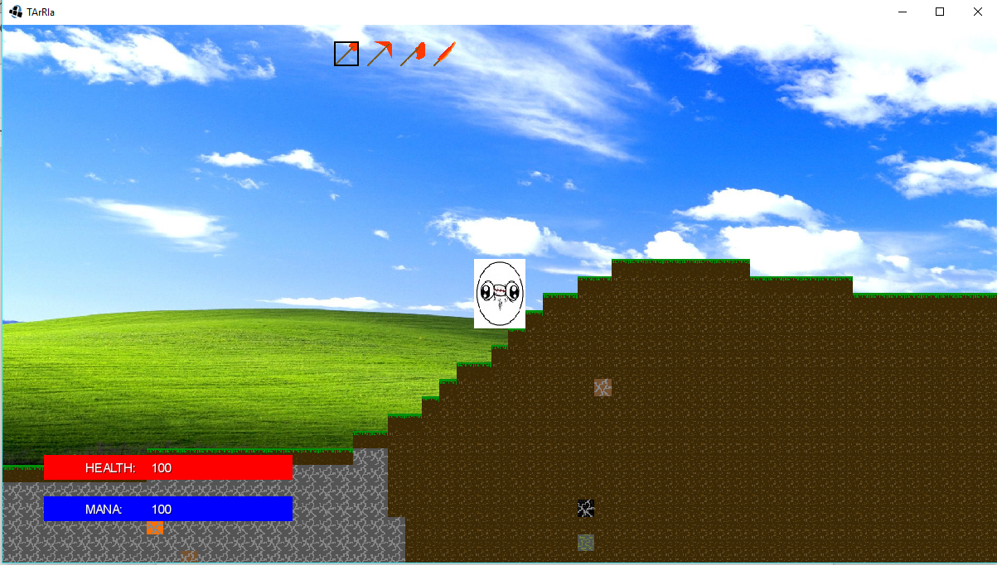

Placing can be done by scrolling to a block in your hotbar at the top of the screen and clicking in an empty spot in the world. You can continue to hold the mouse down and drag to place more blocks.

Self killing can be done by switching to the sword tool. When you click and hold on this tool, your health will decrement and you will die. More on death screen coming later.

When you mine different blocks they get added to your inventory. New blocks will start by going to your hotbar on the top of the screen. When that is full they will go to your inventory. To access your inventory press ‘i’. You will see something like this.

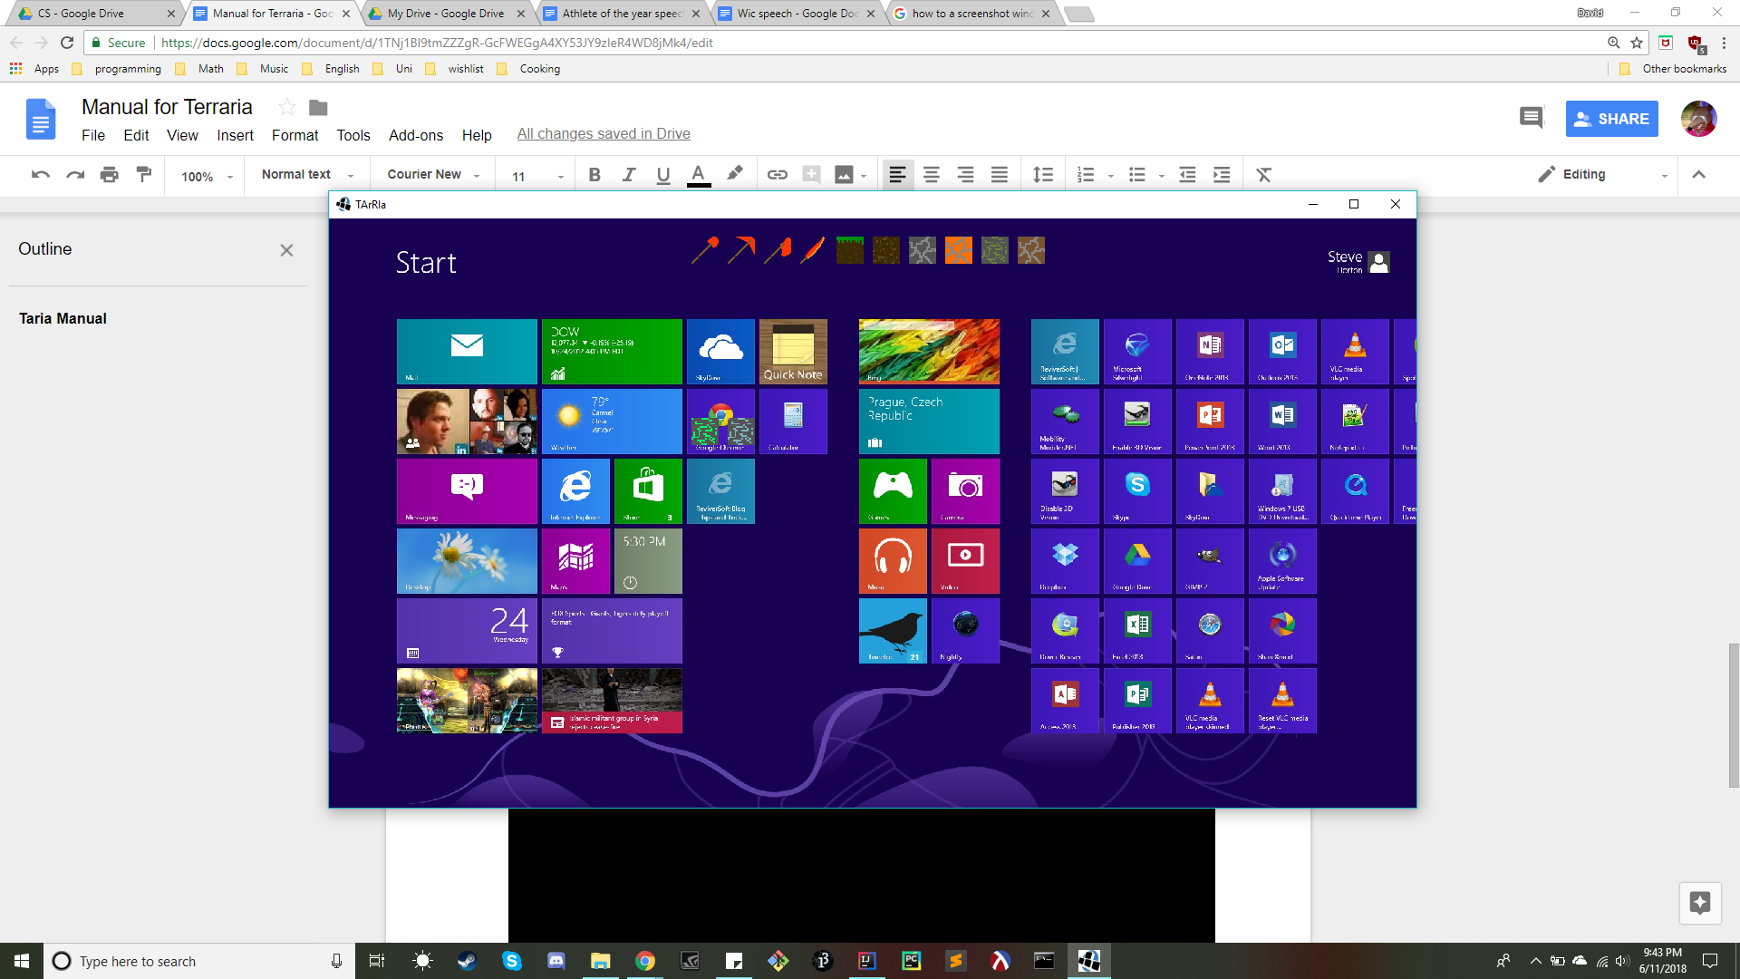

To switch blocks spots in the inventory click on the block you would like to move and then click again on the spot you would like to move it to. Those blocks will switch. You cannot move a block to an empty space. The blocks that you mine will stack up to a limit of 1000. After this limit is exceeded that block type will occupy another inventory space. Press ‘i’ again to return to the play screen.

If you choose to kill your player by clicking with the sword tool, you will find yourself on the death screen that will look something like this.

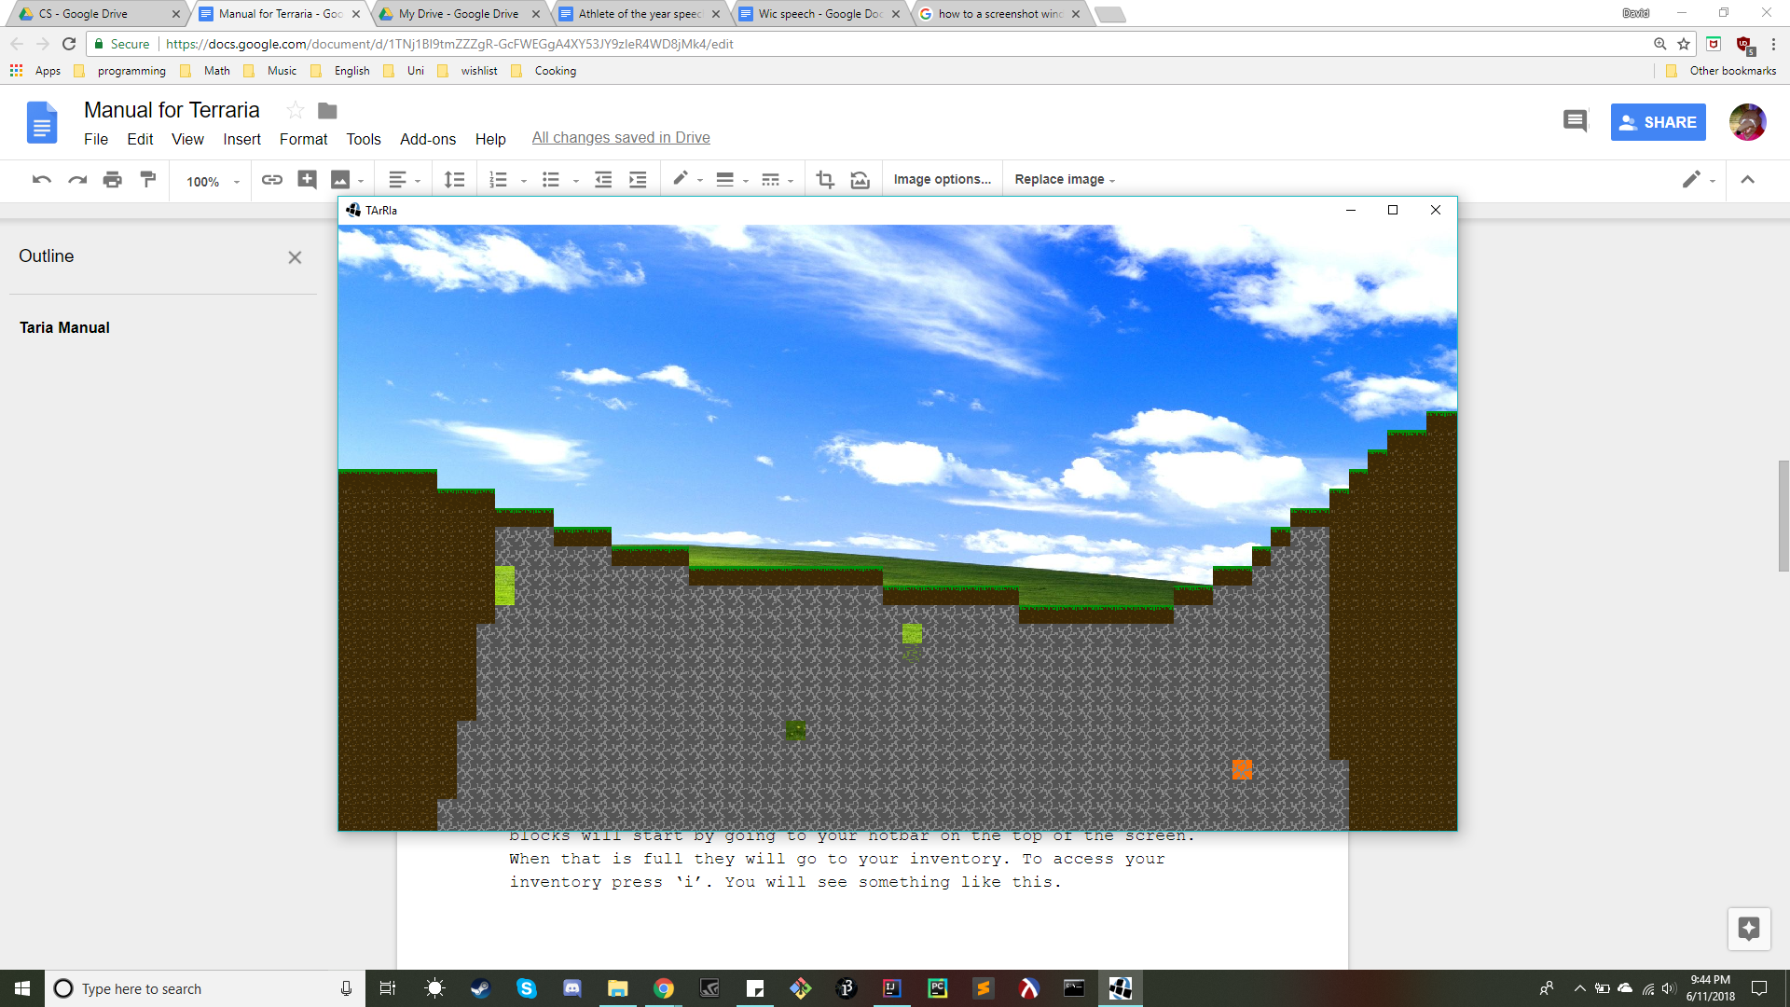

On this screen you have one of two options. You may press ‘r’ to respawn in your current world at your spawn point, or you may press ‘m’ to return to the main menu (the windows logon screen). If you choose to respawn you will revive with limited health, but all of your items still in tact. If you choose to return to the menu, your previous world will be deleted, and you may make a new world. In the new world, you will be returned to full health, and will also lose all of your items. As well the terrain will be changed.